Naomi Novik

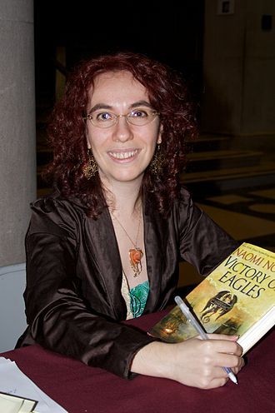

HIS MAJESTY’S DRAGON

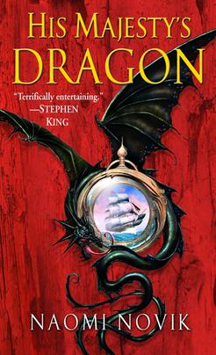

His Majesty's Dragon, published in the UK as Temeraire, is the first novel in the [Temeraire](https://en.wikipedia.org/wiki/Temeraire_(series)" \o "Temeraire (series)) [alternate history](https://en.wikipedia.org/wiki/Alternate_history" \o "Alternate history)/[fantasy](https://en.wikipedia.org/wiki/Fantasy" \o "Fantasy) series by American author [Naomi Novik](https://en.wikipedia.org/wiki/Naomi_Novik" \o "Naomi Novik). It was first published in 2006. It won the 2007 [Compton Crook Award](https://en.wikipedia.org/wiki/Compton_Crook_Award" \o "Compton Crook Award) for best novel in the [science fiction](https://en.wikipedia.org/wiki/Science_fiction" \o "Science fiction)/fantasy genre during 2006 by a first-time author.The story is set during an alternate-history version of the [Napoleonic Wars](https://en.wikipedia.org/wiki/Napoleonic_Wars" \o "Napoleonic Wars), in which [dragons](https://en.wikipedia.org/wiki/Dragon" \o "Dragon) not only exist but are used as a staple of [aerial warfare](https://en.wikipedia.org/wiki/Aerial_warfare" \o "Aerial warfare) in [Asia](https://en.wikipedia.org/wiki/Asia" \o "Asia) and [Europe](https://en.wikipedia.org/wiki/Europe" \o "Europe). The dragons of the story are portrayed as [sapient](https://en.wikipedia.org/wiki/Sapience" \o "Sapience) and intelligent, capable of logical thought and human speech. The series centers primarily on events involving Temeraire (the titular dragon) and his handler, Will Laurence. The first book of the series tells how Laurence, formerly a Captain in the [Royal Navy](https://en.wikipedia.org/wiki/Royal_Navy" \o "Royal Navy), becomes Temeraire's handler, and of their early training in preparation for battles against [Napoleon](https://en.wikipedia.org/wiki/Napoleon" \o "Napoleon)'s aerial fleet.

THRONE OF JADE

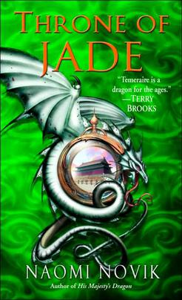

Throne of Jade is the second novel in the [Temeraire](https://en.wikipedia.org/wiki/Temeraire_(series)" \o "Temeraire (series)) [alternate history](https://en.wikipedia.org/wiki/Alternate_history" \o "Alternate history)/[fantasy](https://en.wikipedia.org/wiki/Fantasy" \o "Fantasy) series written by American author [Naomi Novik](https://en.wikipedia.org/wiki/Naomi_Novik" \o "Naomi Novik). It was published by [Del Rey](https://en.wikipedia.org/wiki/Del_Rey_Books" \o "Del Rey Books) first in the United States on April 25, 2006, and was published in the United Kingdom in August 2007 by [Voyager](https://en.wikipedia.org/wiki/Voyager_Books" \o "Voyager Books). The story is set during an [alternate history](https://en.wikipedia.org/wiki/Alternate_history" \o "Alternate history) version of the [Napoleonic Wars](https://en.wikipedia.org/wiki/Napoleonic_Wars" \o "Napoleonic Wars), in which [dragons](https://en.wikipedia.org/wiki/Dragon" \o "Dragon) not only exist but are used as a staple of [aerial warfare](https://en.wikipedia.org/wiki/Aerial_warfare" \o "Aerial warfare) in [Asia](https://en.wikipedia.org/wiki/Asia" \o "Asia) and [Europe](https://en.wikipedia.org/wiki/Europe" \o "Europe). The dragons are portrayed as [sapient](https://en.wikipedia.org/wiki/Sapience" \o "Sapience) and intelligent, capable of logical thought and human speech. The series centers on events involving Temeraire (the titular dragon) and his handler, William Laurence. The first book of the series centered on how Laurence, formerly a captain in the [Royal Navy](https://en.wikipedia.org/wiki/Royal_Navy" \o "Royal Navy), becomes Temeraire's handler, and their early training in preparation for battles against [Napoleon](https://en.wikipedia.org/wiki/Napoleon_I_of_France" \o "Napoleon I of France)'s aerial fleet.

BLACK POWER WAR

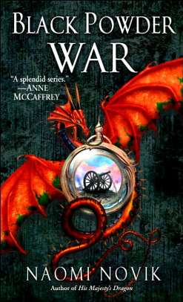

Black Powder War is the third novel in the [Temeraire](https://en.wikipedia.org/wiki/Temeraire_(series)" \o "Temeraire (series)) [alternate history](https://en.wikipedia.org/wiki/Alternate_history" \o "Alternate history)/[fantasy](https://en.wikipedia.org/wiki/Fantasy" \o "Fantasy) series by American author [Naomi Novik](https://en.wikipedia.org/wiki/Naomi_Novik" \o "Naomi Novik). The novel was first published by [Del Rey](https://en.wikipedia.org/wiki/Del_Rey_Books" \o "Del Rey Books) in the [United States](https://en.wikipedia.org/wiki/United_States" \o "United States) on May 30, 2006, and by [Voyager](https://en.wikipedia.org/wiki/HarperCollins" \o "HarperCollins) in the [United Kingdom](https://en.wikipedia.org/wiki/United_Kingdom" \o "United Kingdom) in August 2007. The story is set during an alternate history version of the [Napoleonic Wars](https://en.wikipedia.org/wiki/Napoleonic_Wars" \o "Napoleonic Wars), in which [dragons](https://en.wikipedia.org/wiki/Dragon" \o "Dragon) not only exist but are used as a staple of [aerial warfare](https://en.wikipedia.org/wiki/Aerial_warfare" \o "Aerial warfare) in [Asia](https://en.wikipedia.org/wiki/Asia" \o "Asia) and [Europe](https://en.wikipedia.org/wiki/Europe" \o "Europe). The dragons of the story are portrayed as [sentient](https://en.wikipedia.org/wiki/Sentience" \o "Sentience) and intelligent, capable of logical thought and human speech. The series centers primarily on events involving Temeraire (the titular dragon) and his handler, William Laurence.

EMPIRE OF IVORY

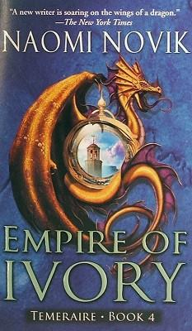

Empire of Ivory is the fourth novel in the [Temeraire](https://en.wikipedia.org/wiki/Temeraire_(series)" \o "Temeraire (series)) [alternate history](https://en.wikipedia.org/wiki/Alternate_history" \o "Alternate history)/[fantasy](https://en.wikipedia.org/wiki/Fantasy" \o "Fantasy) series by American author [Naomi Novik](https://en.wikipedia.org/wiki/Naomi_Novik" \o "Naomi Novik). Set in [Africa](https://en.wikipedia.org/wiki/Africa" \o "Africa), the novel follows William Laurence and his dragon Temeraire's search for a cure to the disease that has paralyzed the dragon community. Novik visited [southern Africa](https://en.wikipedia.org/wiki/Southern_Africa" \o "Southern Africa) in search of places in the fourth novel.

Empire of Ivory was released in paperback in North America by [Del Ray](https://en.wikipedia.org/wiki/Del_Rey_Books" \o "Del Rey Books) on September 25, 2007. The British hardcover edition was published by [Voyager](https://en.wikipedia.org/wiki/HarperCollins" \o "HarperCollins) on November 5, 2007.

Laurence and Temeraire arrive back in the [United Kingdom](https://en.wikipedia.org/wiki/United_Kingdom_of_Great_Britain_and_Ireland" \o "United Kingdom of Great Britain and Ireland), following their evacuation of [Danzig](https://en.wikipedia.org/wiki/Danzig" \o "Danzig) in [Black Powder War](https://en.wikipedia.org/wiki/Black_Powder_War" \o "Black Powder War). Their relief at arriving safely is short-lived as [Napoleon](https://en.wikipedia.org/wiki/Napoleon" \o "Napoleon) continues his preparations for an [invasion of the British Isles](https://en.wikipedia.org/wiki/Napoleon's_planned_invasion_of_the_United_Kingdom" \o "Napoleon's planned invasion of the United Kingdom). When questioned about the lack of British air support for the Prussians, Laurence discovers that Britain had no dragons to spare: a flu-like epidemic has infected the greater part of them, and British science has yet to devise a cure. To combat it, Temeraire, Iskierka and the ferals are forced to fly frantic patrols, both as a show of force and to prevent Napoleon from getting reconnaissance in over the contaminated coverts; at one point Temeraire is forced to knock a French courier-dragon, Sauvignon, out of the sky and down into one of the coverts, risking infection himself.

VICORY OF EAGLES

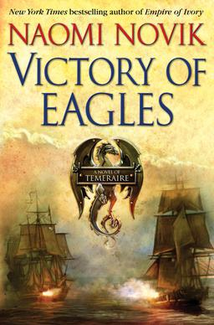

Victory of Eagles is the fifth novel in the [Temeraire](https://en.wikipedia.org/wiki/Temeraire_(series)" \o "Temeraire (series)) [alternate history](https://en.wikipedia.org/wiki/Alternate_history" \o "Alternate history)/[fantasy](https://en.wikipedia.org/wiki/Fantasy" \o "Fantasy) series by American author [Naomi Novik](https://en.wikipedia.org/wiki/Naomi_Novik" \o "Naomi Novik). The series follows the actions of William Laurence and his dragon, Temeraire.

The book was released in hardcover in [North America](https://en.wikipedia.org/wiki/North_America" \o "North America) and the [United Kingdom](https://en.wikipedia.org/wiki/United_Kingdom" \o "United Kingdom) by [Voyager Books](https://en.wikipedia.org/wiki/Voyager_Books" \o "Voyager Books) on July 8, 2008.

As the novel begins, William Laurence is gaoled aboard [HMS Goliath](https://en.wikipedia.org/wiki/HMS_Goliath_(1781)" \o "HMS Goliath (1781)), imprisoned against Temeraire's good behavior. Whilst aboardship, he joins the crew in fighting off the [Grande Armée](https://en.wikipedia.org/wiki/Grande_Arm%C3%A9e" \o "Grande Armée), who supported by the Armée d'Air are [attempting to invade Great Britain](https://en.wikipedia.org/wiki/Napoleon's_planned_invasion_of_the_United_Kingdom" \o "Napoleon's planned invasion of the United Kingdom). They succeed, and Laurence is reported to have been [killed in action](https://en.wikipedia.org/wiki/Killed_in_action" \o "Killed in action) when Goliath is sunk. Temeraire, languishing at the breeding grounds at [Pen y Fan](https://en.wikipedia.org/wiki/Pen_y_Fan" \o "Pen y Fan), receives this intelligence and loses any desire to remain quiet and well-behaved. Instead, fired partially by patriotism and partially by vengeance, he organizes the many unharnessed dragons of the breeding ground into a [militia](https://en.wikipedia.org/wiki/Militia" \o "Militia), using promises of prizes as an enticement. Enlisting the breeding grounds' (human) supervisory staff as logistical support, he and the other dragons strike south to do what they can against [Napoleon Bonaparte](https://en.wikipedia.org/wiki/Napoleon_Bonaparte" \o "Napoleon Bonaparte). This, of course, results in a merry chase: Laurence, who did not perish aboard Goliath, is mustered by Tharkay, now commissioned in the Aerial Corps, to bring Temeraire back under harness, and he arrives at Pen y Fan perhaps half a day after the dragons move out. The two are reunited outside of [Harlesden](https://en.wikipedia.org/wiki/Harlesden" \o "Harlesden), where Temeraire has already staged and won a decisive victory against a group of [Marshal](https://en.wikipedia.org/wiki/Marshal_of_the_Empire" \o "Marshal of the Empire) [Lefebvre](https://en.wikipedia.org/wiki/Fran%C3%A7ois_Joseph_Lefebvre" \o "François Joseph Lefebvre); in fact, Laurence is intercepted by a courier who is seeking out the commander of the militia (that is, Temeraire) with a [colonel](https://en.wikipedia.org/wiki/Colonel" \o "Colonel)'s [commission](https://en.wikipedia.org/wiki/Officer_(armed_forces)" \o "Officer (armed forces)).

TONGUES OF SERPENTS

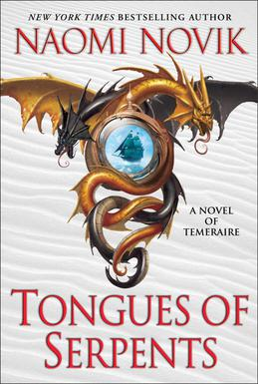

Tongues of Serpents is the sixth novel in the [Temeraire](https://en.wikipedia.org/wiki/Temeraire_(series)" \o "Temeraire (series)) [alternate history](https://en.wikipedia.org/wiki/Alternate_history" \o "Alternate history)/[fantasy](https://en.wikipedia.org/wiki/Fantasy" \o "Fantasy) series by American author [Naomi Novik](https://en.wikipedia.org/wiki/Naomi_Novik" \o "Naomi Novik). This installment follows William Laurence and his dragon, Temeraire's adventures in [Australia](https://en.wikipedia.org/wiki/Australia" \o "Australia).

Tongues of Serpents was released in hardcover and e-Book formats in [North America](https://en.wikipedia.org/wiki/North_America" \o "North America) and the [United Kingdom](https://en.wikipedia.org/wiki/United_Kingdom" \o "United Kingdom) by [Voyager Books](https://en.wikipedia.org/wiki/Voyager_Books" \o "Voyager Books) on July 13, 2010.

The story begins in [New South Wales](https://en.wikipedia.org/wiki/Colony_of_New_South_Wales" \o "Colony of New South Wales), where Laurence has been sentenced to "transportation" for his treasonous actions in [Empire of Ivory](https://en.wikipedia.org/wiki/Empire_of_Ivory" \o "Empire of Ivory). With him is Temeraire; Captain Granby and his firebreathing Kazilik Iskierka; Tenzing Tharkay, his half-Nepalese friend; Tom Riley, [captain](https://en.wikipedia.org/wiki/Sea_captain" \o "Sea captain) of HMS Allegiance which sailed them hence; and three dragon eggs, sent by Admiral Jane Roland to form the foundation of New South Wales' Aerial Corps. Dropping by [Van Diemen's Land](https://en.wikipedia.org/wiki/Van_Diemen's_Land" \o "Van Diemen's Land) to resupply, Allegiance discovered [William Bligh](https://en.wikipedia.org/wiki/William_Bligh" \o "William Bligh), late of [HMS Bounty](https://en.wikipedia.org/wiki/HMS_Bounty" \o "HMS Bounty), exiled there after being deposed in a [military coup](https://en.wikipedia.org/wiki/Military_coup" \o "Military coup), and have since borne him to [Sydney](https://en.wikipedia.org/wiki/Sydney" \o "Sydney). Bligh wishes for Laurence to restore him to the governorship, whereas Colonel [John Macarthur](https://en.wikipedia.org/wiki/John_Macarthur_(wool_pioneer)" \o "John Macarthur (wool pioneer)), architect of the rebellion, wishes them to stay on the sidelines, awaiting a decision from [London](https://en.wikipedia.org/wiki/London" \o "London).

CRUCIBLE OF GOLD

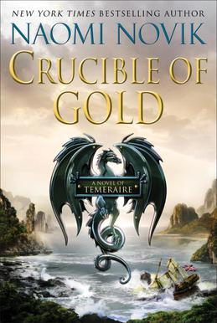

Crucible of Gold is the seventh novel in the [Temeraire](https://en.wikipedia.org/wiki/Temeraire_(series)" \o "Temeraire (series)) [alternate history](https://en.wikipedia.org/wiki/Alternate_history" \o "Alternate history)/[fantasy](https://en.wikipedia.org/wiki/Fantasy" \o "Fantasy) series by American author [Naomi Novik](https://en.wikipedia.org/wiki/Naomi_Novik" \o "Naomi Novik). This installment features the adventures of William Laurence and his dragon, Temeraire, in South America.

Crucible of Gold was released in hardcover and e-Book formats in [North America](https://en.wikipedia.org/wiki/North_America" \o "North America) and the [United Kingdom](https://en.wikipedia.org/wiki/United_Kingdom" \o "United Kingdom) by [Voyager Books](https://en.wikipedia.org/wiki/Voyager_Books" \o "Voyager Books) on March 6, 2012.

William Laurence and Temeraire, who have decided to make a pastoral life for themselves in the [British](https://en.wikipedia.org/wiki/United_Kingdom_of_Great_Britain_and_Ireland" \o "United Kingdom of Great Britain and Ireland) colony of [New South Wales](https://en.wikipedia.org/wiki/Colony_of_New_South_Wales" \o "Colony of New South Wales), are disturbed by the arrival of the [diplomat](https://en.wikipedia.org/wiki/Diplomat" \o "Diplomat) Arthur Hammond, lately assigned to [China](https://en.wikipedia.org/wiki/Qing_dynasty" \o "Qing dynasty), who bears dire news. The [Portuguese colony of Brazil](https://en.wikipedia.org/wiki/Colonial_Brazil" \o "Colonial Brazil) is besieged by forces allied to [Napoleon Bonaparte](https://en.wikipedia.org/wiki/Napoleon_Bonaparte" \o "Napoleon Bonaparte), but not belonging to him: the [Emperor of France](https://en.wikipedia.org/wiki/Emperor_of_the_French" \o "Emperor of the French) has found common cause with the [Tswana](https://en.wikipedia.org/wiki/Tswana_people" \o "Tswana people), now undisputed masters of the African continent. Their stated desire of retrieving all Africans captured and sold by the [slave trade](https://en.wikipedia.org/wiki/Slave_trade" \o "Slave trade) has brought them to Brazil, where the Crown Prince of [Portugal](https://en.wikipedia.org/wiki/History_of_Portugal_(1777%E2%80%931834)" \o "History of Portugal (1777–1834)), [João](https://en.wikipedia.org/wiki/John_VI_of_Portugal" \o "John VI of Portugal), has sought refuge. As Portugal itself is the safe harbor to Britain's latest plan, a ground offensive into [France](https://en.wikipedia.org/wiki/First_French_Empire" \o "First French Empire) itself, Brazil's safety is of paramount importance, and Hammond restores Laurence's commission and captaincy to address the crisis.

BLOOD OF TYRANTS

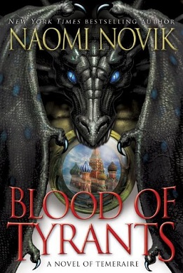

Blood of Tyrants is the eighth novel in the [Temeraire](https://en.wikipedia.org/wiki/Temeraire_(series)" \o "Temeraire (series)) [alternate history](https://en.wikipedia.org/wiki/Alternate_history" \o "Alternate history)/[fantasy](https://en.wikipedia.org/wiki/Fantasy" \o "Fantasy) series by American author [Naomi Novik](https://en.wikipedia.org/wiki/Naomi_Novik" \o "Naomi Novik). It was first published by [Voyager Books](https://en.wikipedia.org/wiki/Voyager_Books" \o "Voyager Books) in August 2013. This installment features the adventures of William Laurence and his dragon, Temeraire, in Japan, China, and Russia, as they attempt to muster up new allies in the year 1812.William Laurence awakens on the shores of [Japan](https://en.wikipedia.org/wiki/Tokugawa_shogunate" \o "Tokugawa shogunate). He finds himself in great confusion: afflicted with [retrograde amnesia](https://en.wikipedia.org/wiki/Retrograde_amnesia" \o "Retrograde amnesia), he remembers nothing of how he came to know [Chinese](https://en.wikipedia.org/wiki/Qing_dynasty" \o "Qing dynasty) nor how he arrived on these shores. He is brought before the local magistrate, Kaneko Hiromasa, and kept in genteel imprisonment for straying outside [Nagasaki](https://en.wikipedia.org/wiki/Nagasaki" \o "Nagasaki), the sole port currently open to European traders. Temeraire, meanwhile, works with the other dragons of his formation to put to rights the Potentate, their dragon transport, which has run aground on a reef during a storm. Having made the ship seaworthy again, they set sail for Nagasaki, where diplomat Arthur Hammond wishes to make some overtures and to locate Laurence. They receive assistance in this matter from a friendly American dragon, John Wampanoag, a merchant captain attempting to expand his business into Japan. However, the only word is that Laurence has escaped: as Kaneko broke the law in giving shelter to a foreigner, his young retainer, Junichiro, absconded with Laurence to protect his master's honor. Temeraire feels additionally slowed by concern for Iskierka, who, after their mating in the previous novel, has produced an egg which must be cared for.

SPINNING SILVER

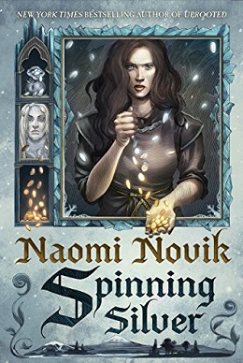

Spinning Silver is a 2018 fantasy novel written by [Naomi Novik](https://en.wikipedia.org/wiki/Naomi_Novik" \o "Naomi Novik). Novik originally published a short story called "Spinning Silver" in The Starlit Wood anthology in 2016 and later expanded it into a novel. Spinning Silver won the American Library Association's [Alex Award](https://en.wikipedia.org/wiki/Alex_Awards" \o "Alex Awards) in 2019, the 2019 [Locus Award for Best Fantasy Novel](https://en.wikipedia.org/wiki/Locus_Award_for_Best_Fantasy_Novel" \o "Locus Award for Best Fantasy Novel), and the 2019 [Audie Award for Fantasy](https://en.wikipedia.org/wiki/Audie_Award_for_Fantasy" \o "Audie Award for Fantasy). Spinning Silver was a 2019 [Hugo Award for Best Novel](https://en.wikipedia.org/wiki/Hugo_Award_for_Best_Novel" \o "Hugo Award for Best Novel) Nominee, a 2018 finalist for the Nebula Award for Best Novel, and a 2018 [Goodreads Choice Award](https://en.wikipedia.org/wiki/Goodreads_Choice_Award" \o "Goodreads Choice Award) Nominee for Fantasy. The novel is loosely based on the tale of [Rumpelstiltskin](https://en.wikipedia.org/wiki/Rumpelstiltskin" \o "Rumpelstiltskin)..

The story of Spinning Silver unfolds in the voices of several characters, but primarily in the voices of three young women who struggle against strong evil forces, in an imaginary medieval eastern European kingdom called Lithvas.

Over the last seven years, Lithvas has been suffering from long, brutal winters that are slowly killing its people. Miryem Mandelstam, a young Jewish girl, takes over her father's moneylending business to save her family from debt. A village girl, Wanda, becomes the Mandelstams' servant, and she and her brothers become close with them. One night Miryem, flush with her financial success, brags to her mother that she can “turn silver into gold”. Her boast is overheard by the Staryk, a race of [fae](https://en.wikipedia.org/wiki/Fairy" \o "Fairy) creatures who emerge from their own world every winter to raid human settlements, and Miryem receives three deliveries of magical silver. Realizing that the Staryk will kill her if she does not give them gold in exchange, she has the metal made into three pieces of jewellery to sell. However, after the sale of the second piece, Miryem demands payment for her work; to Miryem’s horror, the Staryk king tells her that after the third, her "reward" will be marriage to him.